Ly Tu Trong Technical College of Ho Chi Minh City
Basic Science Department - English group
Subject: TOEIC 2
Class: 15CĐ-Ô1 Classroom: C.2.2.05
Date of teaching: 02/06/2016
Allowed time: 1 period
Lecturer: Phạm Thị Thu Hiền
LESSON PLAN
UNIT 6: VOICE
I. OBJECTIVES
By the end of the lesson, the students will be able to:
-Review knowledge about Passive Voice in previous lesson.
-Know techniques to do and practice part 5 and part 6 in Toeic test.
II. TIME
-45 minutes.
III. METHOD
-Integrated, communicative oriented teaching approach.
IV. TECHNIQUES
-Pair work.
-Group work.
V. TEACHING AIDS
-Text book.
-Black board, chalk.
-Pictures for teaching vocabularies.
-Cassette player, amplifier, microphone.
-Hand-outs for sub-exercises
VI. PROCEDURE
A.Greetings.
B.Checking students’ attendance: 3 minutes
C. Checking the old lesson: 5 minutes
Passive Voice (Deliver handouts)
D.New lesson
PART 5:  Incomplete Sentences  PART 6:  Incomplete Texts  Questions 1-8 | 25’  10’ | - T preteaches some new words.  Vanish (v): using synonym  Remind of (v): using explanation.    Experiment (n): using picture.  Calculator (n): using picture.      Space probe (n): using picture  Accustom (v): explanation    Earthquake (n): using picture  Fantastic (adj): using synonym  - T sets time for Ss to do part 5  - T asks Ss to write down their answers on board.  -T encourages Ss to explain the reason why they choose that answer.  - T checks Ss’ understanding and corrects the answers  - T teaches relating words.  Grade(n): using synonym  Opportunity (n): using synonym  In charge of (v): using example  Take part in (v): using synonym  - T asks Ss to do part 6 in pairs  - T calls on some students to write their answers on the board.  - T checks Ss’ understanding and gives feedback. | -Ss take note new words.  -Ss do part 5.  -Ss write down their answers on the board.  -Ss explain why.  -Ss check the answers.  Answers:  1.D 2.B 3.C 4.D  5.D 6.C 7.C 8.D  9.B 10.D 11.C 12.C  13. C 14.A 15.C  -Ss take note.  -Ss work in pairs.  -Ss correct the answers.  Answers:  Question 1 through 4:  1.A 2.A 3.B 4.D  Question 5 through 8  5.D 6.C 7.C 8.D

VII. SUMMARY OF UNIT 6: 2 minutes.
- T reminds Ss about:
+Voice.
+ Vocabulary and Grammar Exercises
+ Part 5 and Part 6 in Mini Test.

VIII. HOMEWORK:
- Ss have to do again all the exercises.
- Ss prepare for the new lesson.

X.HANDOUTS:
Exercise: Transfer from Active to Passive
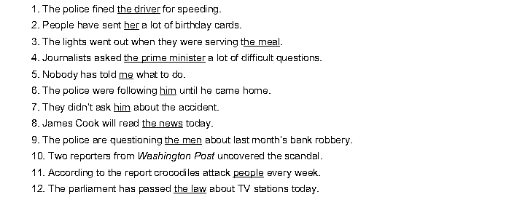
X. SELF-ASSESSMENT:
- The teaching methods are good because:
+ There are facilities and materials for students to study better.
+ The teacher’s preparation is careful.

May, 30th 2016
ADOPTION OF ENGLISH GROUP Teacher’s signature

Phạm Thị Thu Hiền

